**PROJECT REPORT**

**INTELLIGENT CUSTOMER HELP DESK WITH SMART DOCUMENT UNDERSTANDING**

**-Agnigundala Meghana**

SBID : SB20200003600

* **INTRODUCTION**

**1.1 Overview**

**Intelligent Customer Help Desk with SDU**

A chatbot is an Artificial Intelligence (AI) based computer program also known as digital assistants simulates human conversations with a user in natural language through messaging applications, websites or through mobile apps. The typical customer care chatbot can answer simple questions but it takes too long to understand.

But here we will be creating an AI based chatbot which can understand the documents and fetch the answers for those documents. We will use the Smart Document Understanding feature of Watson Discovery to fetch the answers easily for the queries asked by the users.

In this project, an AI based chatbot is developed using IBM Watson Assistant and the Watson Discovery Service. The project includes the following:

* A dialog skill(chatbot) using Watson Assistant is built.
* Smart Document Understanding feature is used to build an Enhanced Watson Discovery collection.
* IBM Cloud Functions is used to create a web action.
* A Web Application using Node-RED is built.
* Deploy the app on IBM Cloud.

**1.2 Purpose**

 The AI based chatbot is a web application that acts as a simple user interface that integrates with the IBM Watson Discovery and IBM Cloud Functions to answer the queries using Watson Assistant:

* If the customer question is about the operation of a device, we will use the webhook feature of Watson Assistant to pass the question onto our Watson Discovery Service, which has been pre-loaded with the device’s owners manual.
* To take it a step further, we will use the Smart Document Understanding feature of Watson Discovery to train it on what text in the owner’s manual is important and what is not. This will improve the answers returned from the queries.

* **LITERATURE SURVEY**

**2.1 Existing Problem**

The typical chatbot or Watson Assistant Dialog skill(chatbot) can answer simple questions, such as store locations and hours, directions, and maybe even making appointments.

When a question falls outside of the scope of the pre-determined question set, the option is typically to tell the customer the question isn’t valid or offer to speak to a real person.

Every time speaking to a person(executive) would a be a tough task. That would not help the customers get relevant answers and might not help the customers in an easy way.

**2.2 Proposed Solution**

To overcome this problem, a simple web application can be created using the Node-RED and IBM Watson Discovery Service.

* The document is annotated using Watson Discovery Smart Document Understanding.
* The user interacts with the app UI to request relevant information.
* The Dialog between the user and back-end server is coordinated using a Watson Assistant dialog skill.
* If the user asks a product operation question, a search query is passed to a predefined IBM Cloud Functions web action.
* The IBM Cloud Functions action will query the Watson Discovery Service and return the results.

* **THEORETICAL ANALYSIS**

**3.1 Block Diagram**

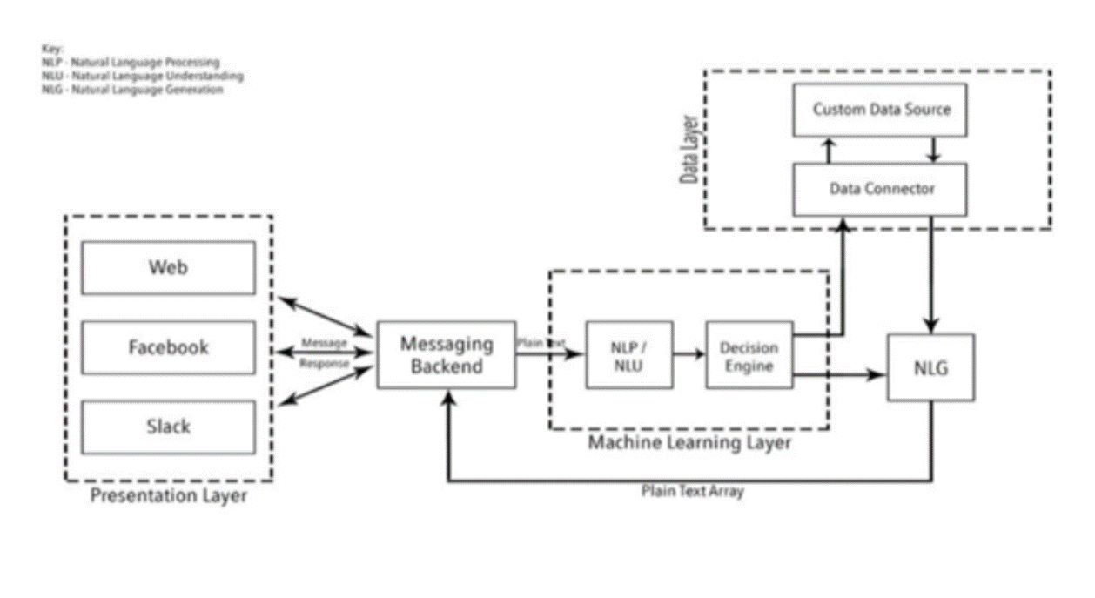

**3.2 Hardware/Software Designing**

This web application can be created using Node.js and Node-RED using some JavaScript and HTML concepts on the IBM cloud.

A dialog skill can be created using Watson Assistant which contains the training to respond to the customer queries and can be added to our Assistant.

* Here we will create intents i.e the questions asked by the users and entities to configure them under particular content.
* Dialog is created i.e the response given by the bot to the user.

Smart Document Understanding feature of Watson Discovery is used to train the document on what text in the document is important and what is not.

* Here the single document will be divided into several documents based on a specific field. This will improve the answers returned from the queries.

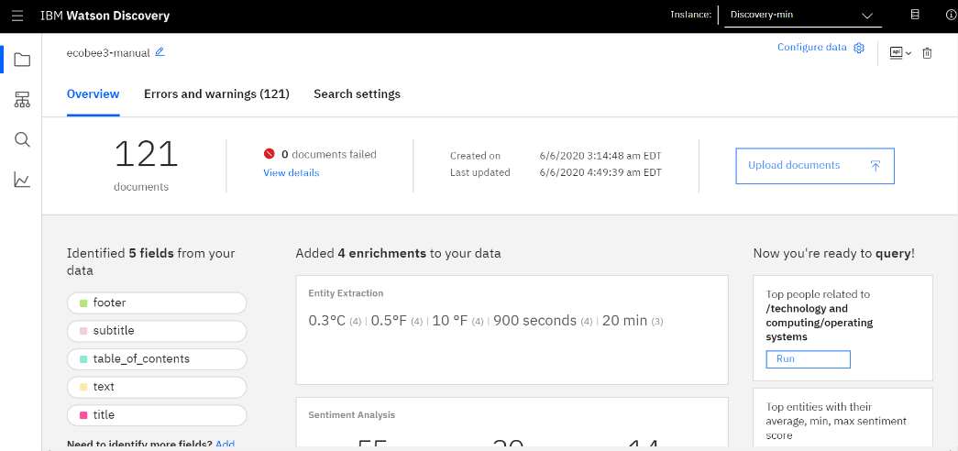

The IBM Cloud Functions is used to create a web action that allows Watson Assistant to post queries to Watson Discovery.

* Here a web action is created and we will invoke a code that has a dedicated URL that will be integrated with the dialog skill of the Watson Assistant.
* Whenever a question out of the scope is asked, it will return relevant information from the document.

**Query Builder**

In the UI of the application the user can type in the query. The query is then searched in the dialog skill and Watson Discovery Service and the result will be displayed in the UI.

* The user will ask a query which will be sent to the Watson Assistant(chatbot).
* The Cloud Functions will allow the assistant to post queries to Watson Discovery and the bot will return relevant answers to the user.

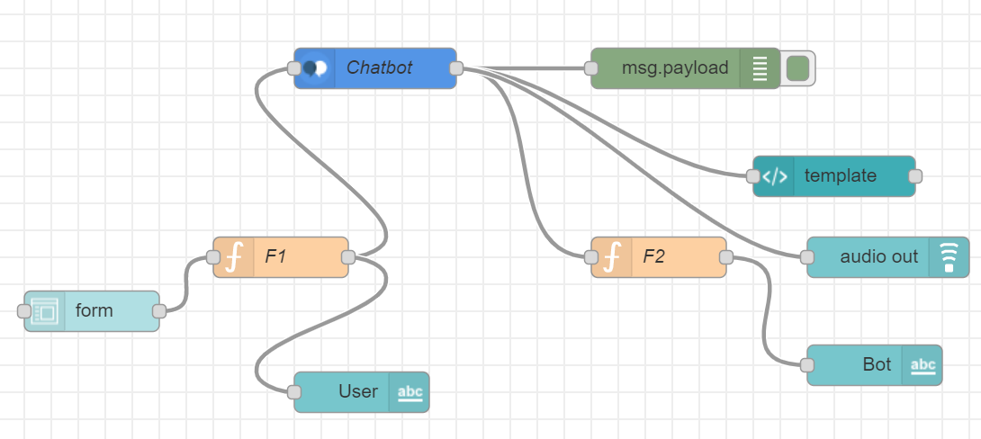

* **FLOWCHART**

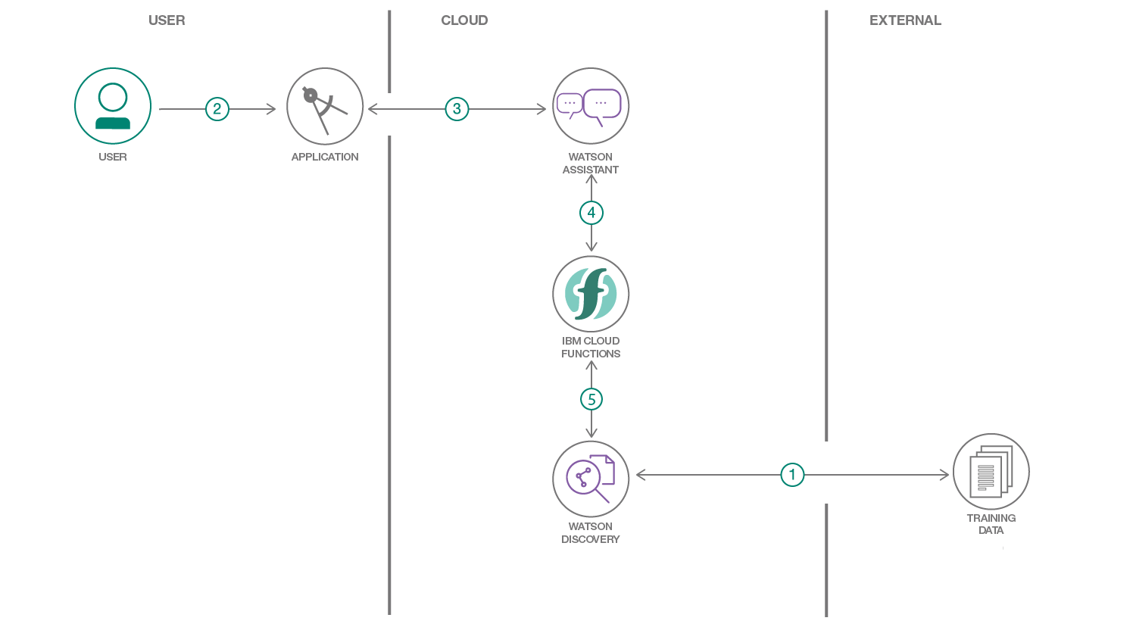

* **RESULT**

The home page of the Application is as follows:

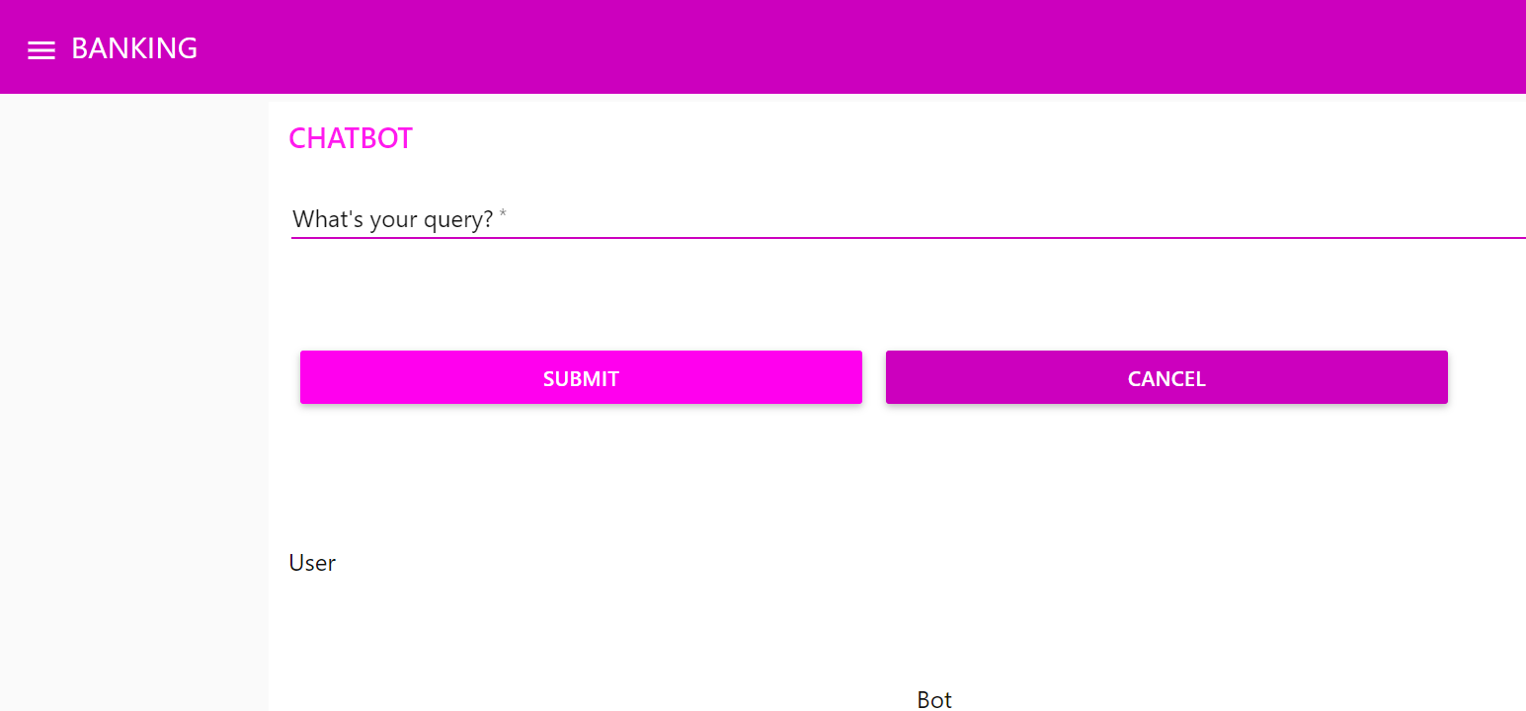

When the user asks a query it will be sent to the Watson Assistant using cloud functions and relevant information is acquired using Smart Document Understanding of Watson Discovery as shown below:

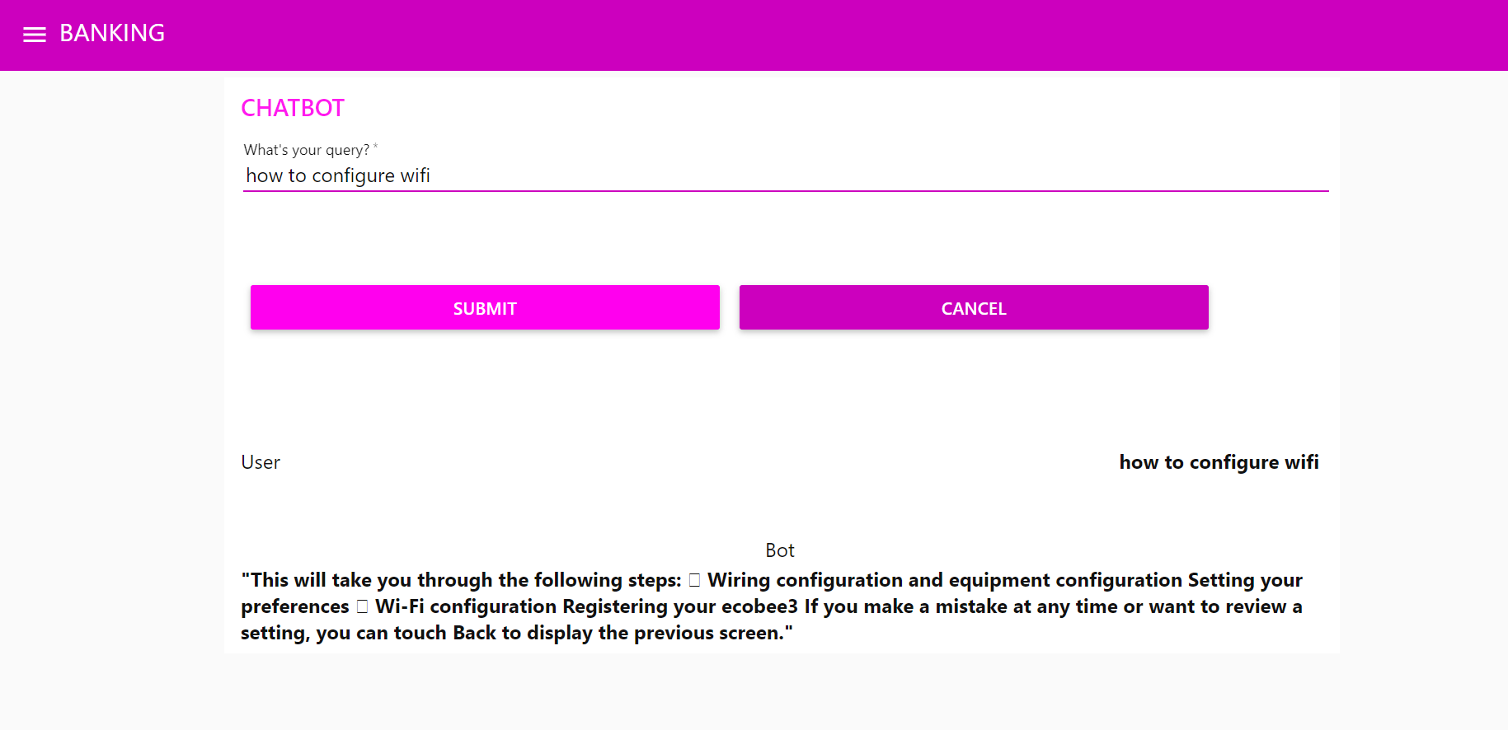

An example of the dialog between the user and the bot in Watson Assistant:

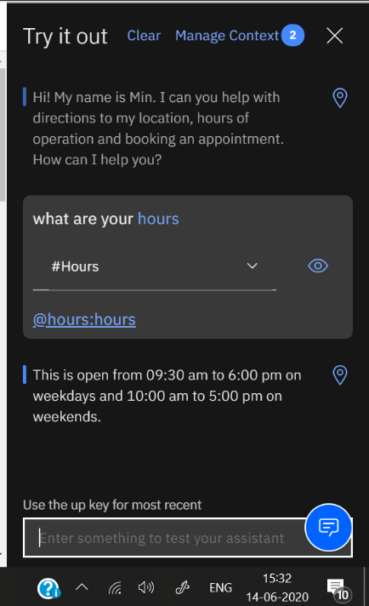

* Here when a query is asked it goes under the particular intent i.e #Hours, entity @hours: hours and the respective dialog will be given.

UI URL: <https://api.eu-gb.assistant.watson.cloud.ibm.com/instances/266cf489-c6f4-4334-92c4-5e9f5416c55a>

**ADVANTAGES & DISADVANTAGES**

**Advantages:**

* The user can interact with Watson Assistant dialog skill(chatbot) at ease.
* It is reliable.

**Disadvantages:**

* Limited results are displayed on the Application UI.
* It may not be that relevant sometimes.
* **CONCLUSION**

This project thus creates a web application that gives more relevant answers to the queries using Watson Discovery Service.

There is more to building chatbots and conversational UI than just plugging tools, services, and data together. The user should be able to get the job done by having a conversation with the bot without having to think too much and within a smile on their face.

From my perspective, chatbots or smart assistants with artificial intelligence are dramatically changing businesses. There is a wide range of chatbot building platforms that are available for various enterprises, such as e-commerce, retail, banking, leisure, travel, healthcare, and so on.

* **FUTURE SCOPE**

The clearest use of chatbots right now is in customer service and online ordering, where it can automate (and in some cases solve) customer issues or complete orders without human interaction.

* Adding Natural Language Processing in the Bot to understand the User Statements.
* Adding Sentiment Analysis to predict User Sentiment during the Chat.
* Use Voice Capabilities of the Bot.
* Use Voice Recognition with Bot.
* **APPENDIX**

**A. Source code**

Git url: <https://github.com/SmartPracticeschool/llSPS-INT-1802-Intelligent-Customer-Help-Desk-with-Smart-Document-Understanding>

PROJECT DEMONSTRATION VIDEO :

YOUTUBE LINK - https://youtu.be/0BCy7f8bwn0